SECURE CODING

LAB – 4

* G JAY VENKAT
* 18BCN7112

The pyinstaller is used for the sake of converting of .py file to a executable (.exe). Here Hello.py is converted into Hello.exe.





For scheduling a task we use the command **Schtasks**.



The below is the task name “Executer” scheduled to run a calculator for every 5 mins starting from 9am to indefinitely.



The below is the creation of the task name Executer2 which runs notepad daily from start time 5pm to 5:40 pm.







Task name Defragment this runs daily from starting 10AM to run the defrag command on the cmd.



**Powercfg:**

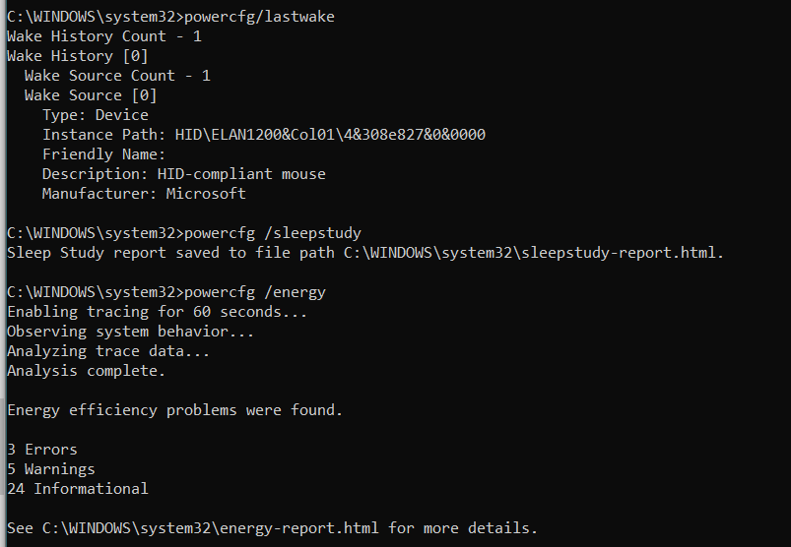

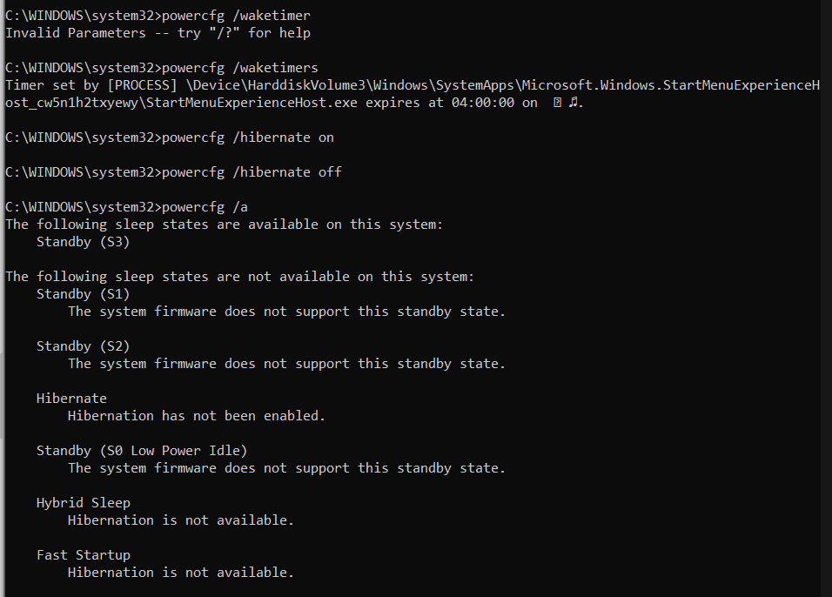

**Scripts to lock the windows screen and to clear the recycle bin:**

1. @echo off

rundll32.exe user32.dll, LockWorkStation

Cls

1. ​rmdir /s %systemdrive%\$Recycle.bin

**● Create a task name “Reg.no_Task1” to run on a specific time​**



**● Change the time of the scheduled task ​**

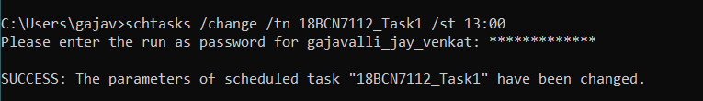

**● Delete the scheduled task ​**

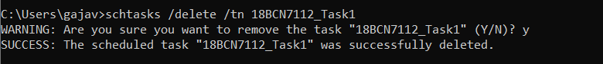

**● Schedule an another task to run only on Weekdays​**



**● Schedule an another task to run only on Weekends​**

